**THE CHIOS SOCIETY OF GREATER WASHINGTON, D.C.**

**Invites you to their Annual Picnic**



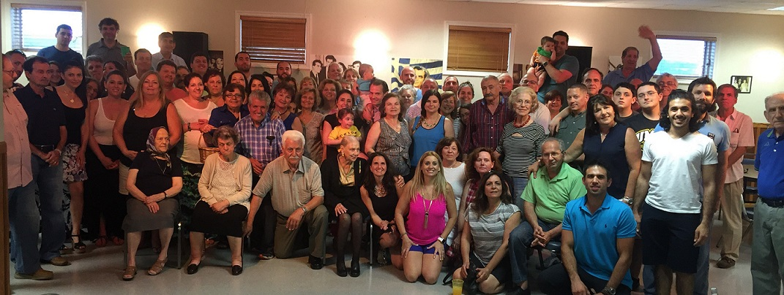

**SUNDAY, JUNE 24, 2018**

**3:00 P.M.**

**St. Theodore’s Greek Orthodox Church**

**7101 Cipriano Road, Lanham, MD 20706**

**Bring a dish to share and join in the fun!!**

**http://www.chios-society.org/**