The Chios Society of Greater Washington Area
Join us on Sunday, March 27, 2022
for the annual Greek Independence Day Parade
Baltimore, MD
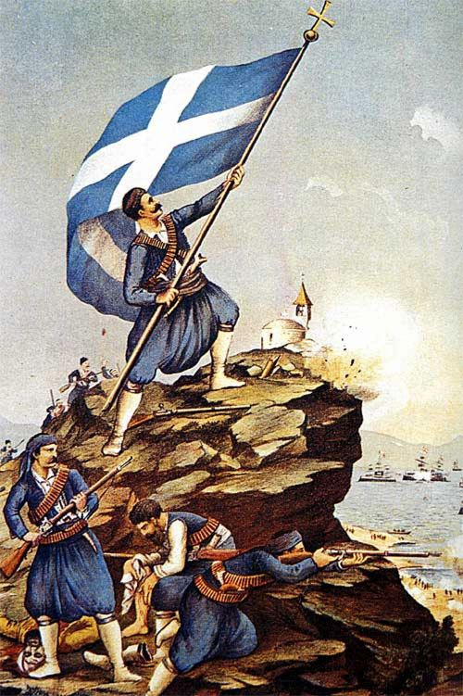
We will meet at 1:30pm Under the Eastern Avenue bridge

Visit our website at www.chios-society.com

